While loop

Dim i As Integer
i = 1
While i <= 10
Console.WriteLine(i)
i = i + 1
If i > 5 Then
Exit While 'exit loop when i is greater then 5

End If

End While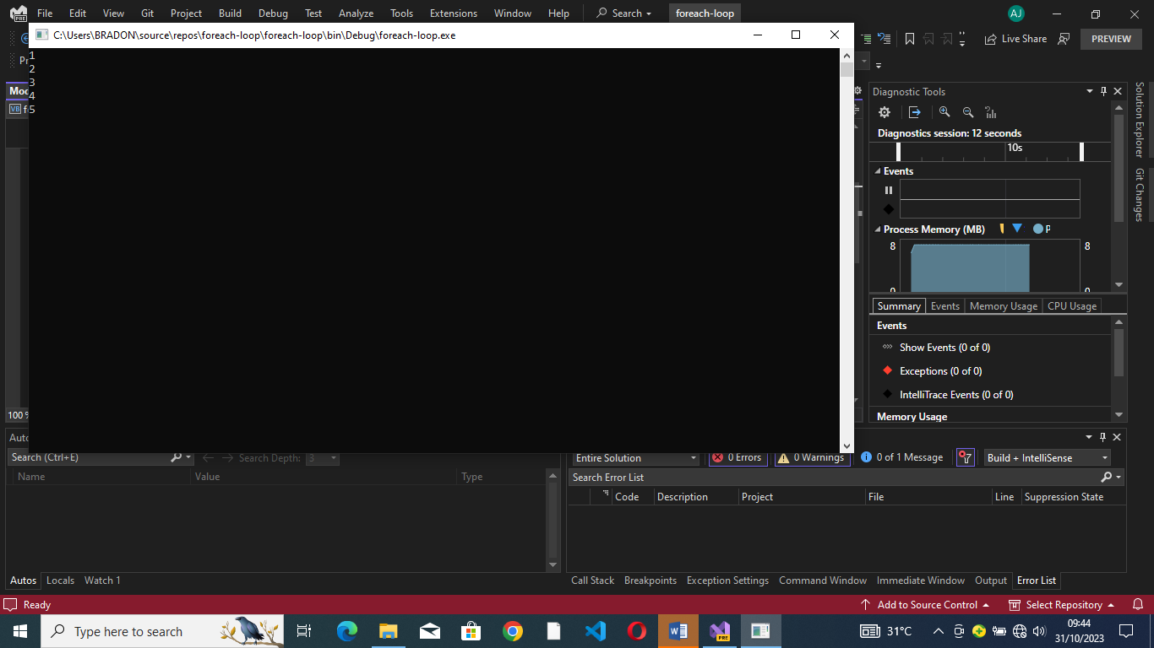

Do while loop
Dim i As integer
Do While i <= 10
Console.WriteLine(i)
i += 1
Loop
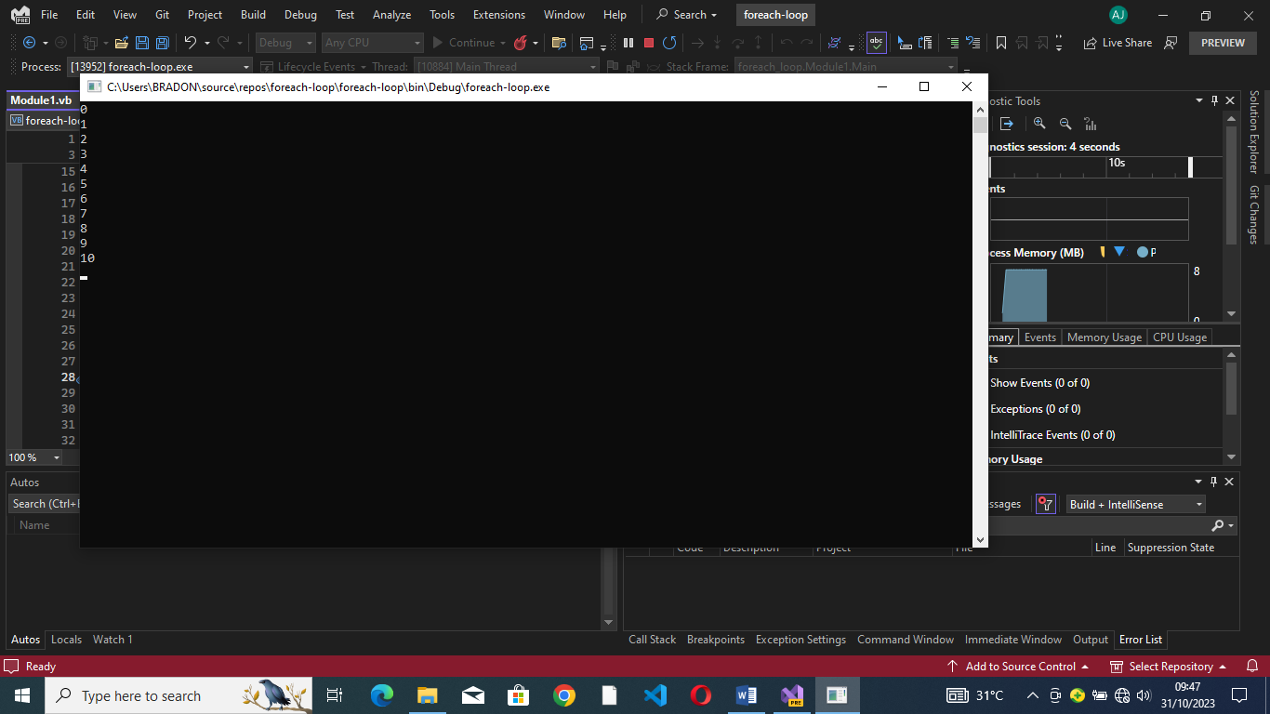

Sub Main()
Dim i As Integer
Console.Write("print numbers from 1 to 10 on the screen")
For i = 0 To 10
Console.WriteLine(i)
Next
Console.ReadLine()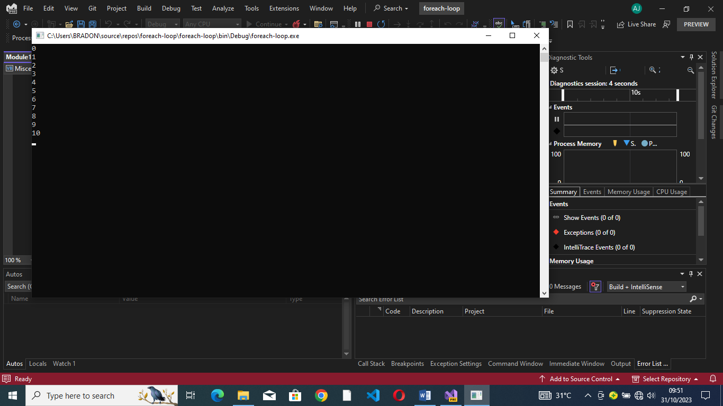
Conditional statement
Dim age As Integer
Console.WriteLine("please enter your age")

age = Console.ReadLine()
If age < 12 Then
Console.WriteLine("your ticket price is 3000frs")
ElseIf age >= 12 And
age <= 18 Then
Console.WriteLine("your ticket is 5000frs")
ElseIf age > 18 Then
Console.WriteLine("your ticket is 10000frs")

End If
Console.ReadLine()

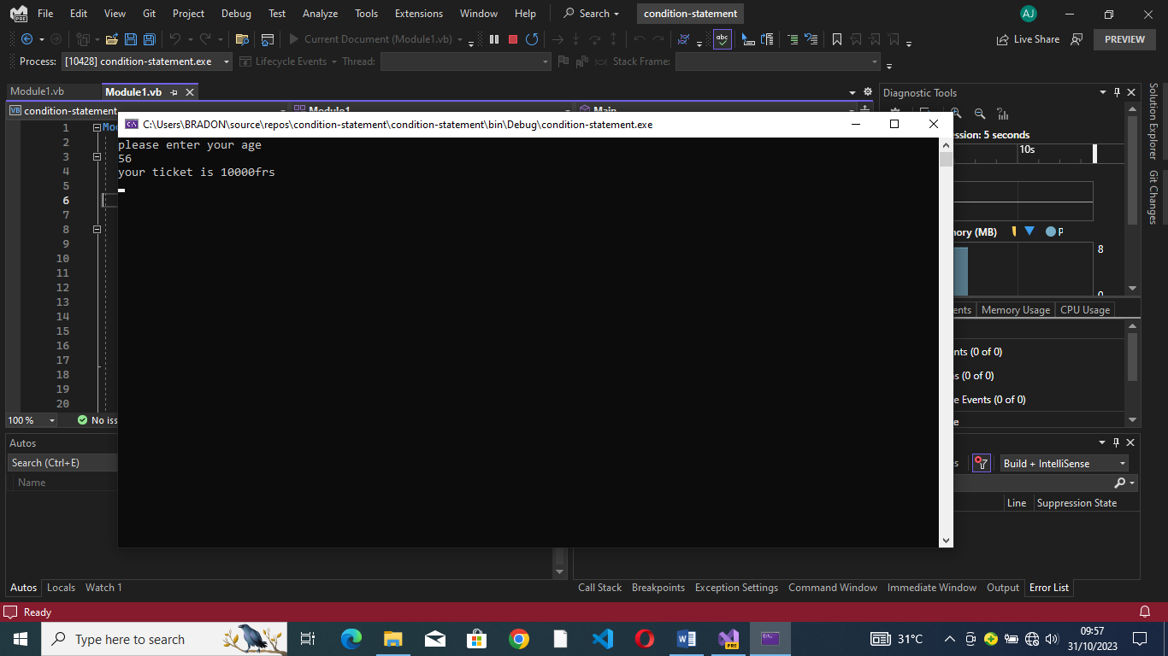
Dim a As Integer
For a = 1 To 5
Console.WriteLine("******")
Next
Console.ReadLine() 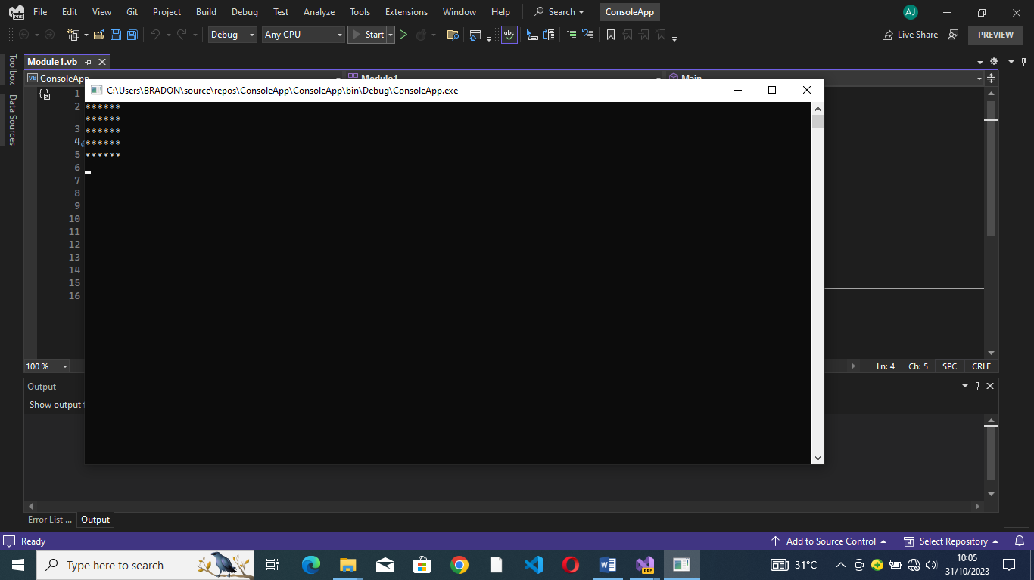

Dim b As Double
Dim d As Boolean
Dim a As integer
a = Console.ReadLine
b = Console.ReadLine
d = Console.ReadLine

Console.WriteLine("a={0},b={0},d={0}", a, b, d)

Console.ReadLine()
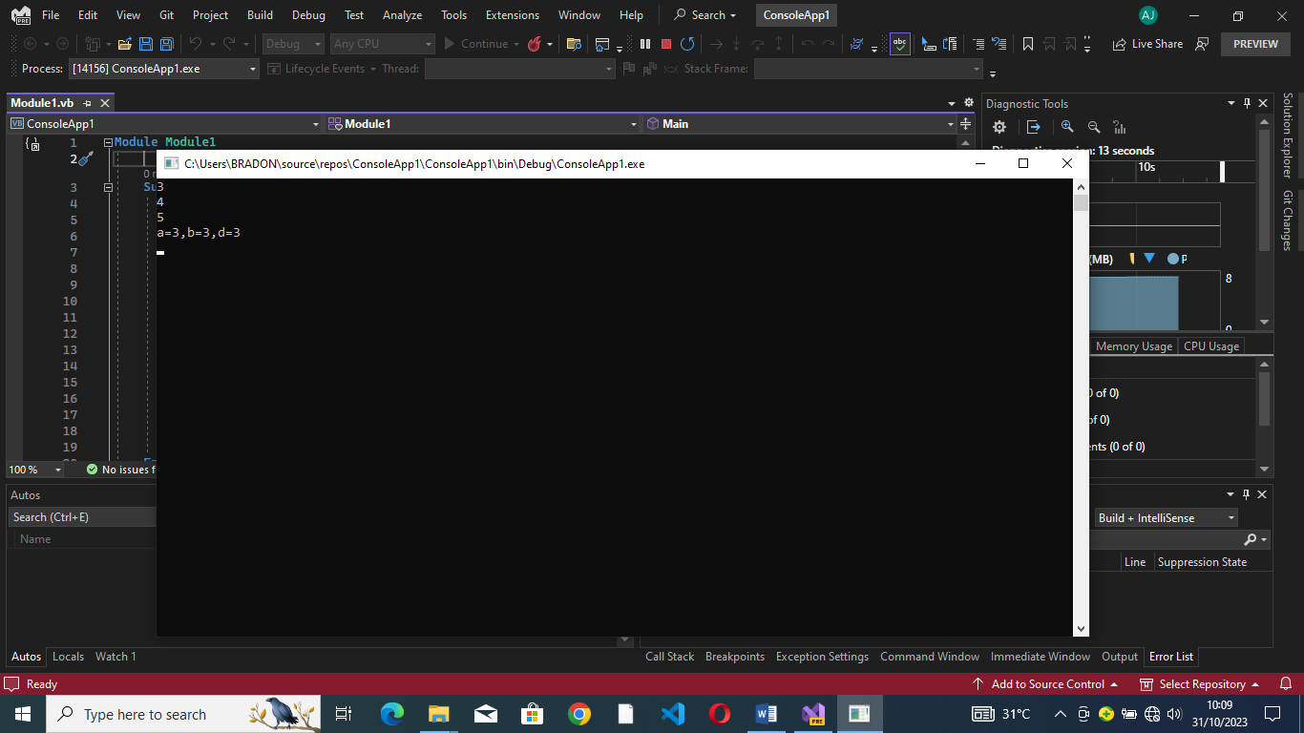
Dim Age As Integer
Age = Console.ReadLine
Console.WriteLine("my Age is {0}", Age)
Console.ReadLine()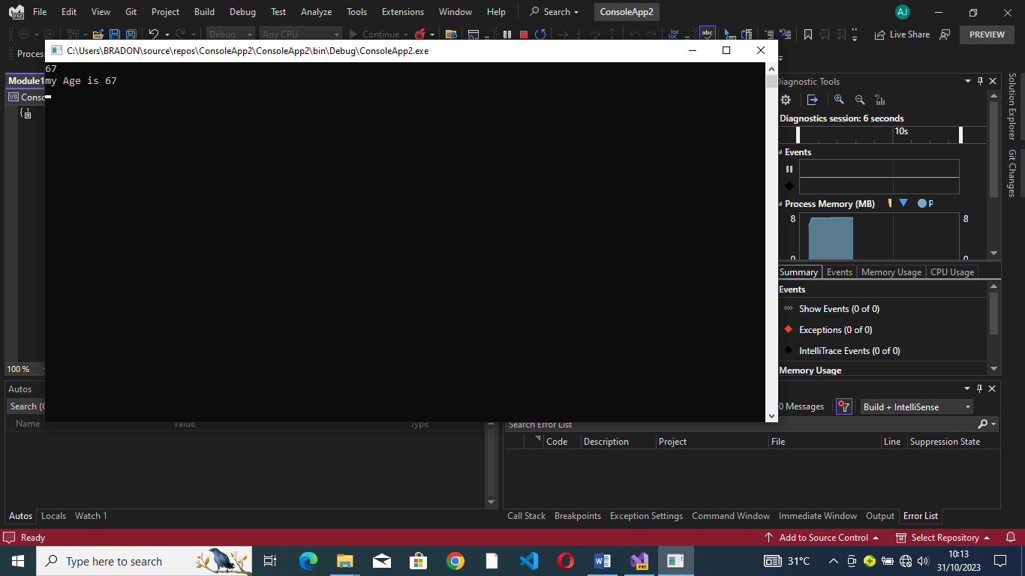
Dim name As String
Console.WriteLine("enter your age")
name = Console.ReadLine
Console.WriteLine("your age is {0}", name)
Console.ReadLine()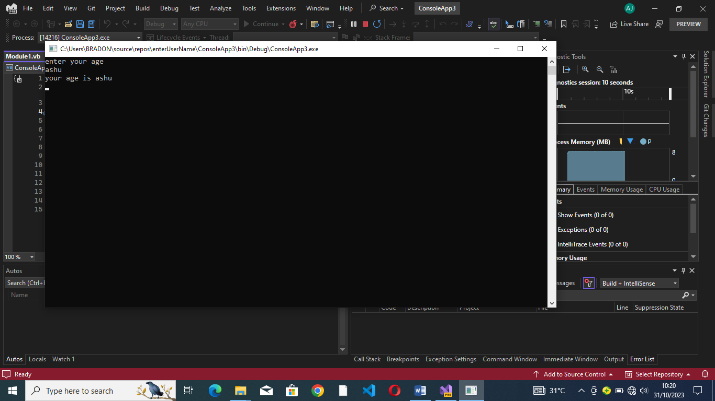
Dim num1 As Integer
Dim num2 As Integer
Dim num3 As Integer
Console.WriteLine("enter the number to be operated ")
num1 = Console.ReadLine()

num2 = Console.ReadLine
num3 = num1 + num2
Console.WriteLine("addition pf the two is {0}", num3)
num3 = num1 - num2
num3 = num1 * num2
Console.WriteLine("multiplication = {0}", num3)
Console.ReadLine()
